

# Proximity Sensor Switches

Proximity sensor switches are highly sensitive devices that do not require a physical touch to activate. They are a perfect alternative switch for people who do not have the ability to apply pressure to a switch.

These switches might be helpful for persons with limited upper-body mobility resulting from spinal cord injuries, multiple sclerosis, ALS, muscular dystrophy, cerebral palsy, brain injuries, stroke, or amputation.

**Type of accessory:** Proximity Switch

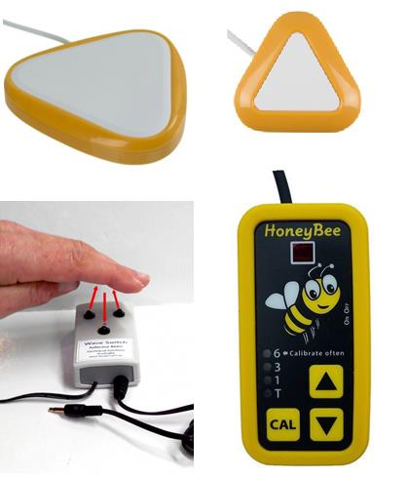

## How do you use these accessories?

Wave your hand or other portion of your body close enough to the switch to activate any device that can work in switch mode. This will allow you to select and access apps and functions in your smart device, including call and messaging services.

A Bluetooth switch interface is needed in order for this device to connect to a smartphone or tablet.

An example of how to use these devices can be seen in the following video:

[Example of Sensor Switch use (Video](https://www.youtube.com/watch?v=l-FxdaDLBMo))

## These accessories connect to phones via:

Audio Jack: No

Bluetooth: Yes (requires a Bluetooth Interface Switch)

Wi-Fi: No

Micro USB: No

Other: No

## Is there any other piece of equipment required for this accessory to work properly with a phone?

Yes. Proximity sensor switches do not have Bluetooth connectivity, which is usually required to connect to a smartphone or tablet. Therefore you need a “Bluetooth Switch Interface” which is a device that acts as a connection bridge between your corded switch and your smartphone or tablet.

Some Bluetooth switch interfaces in the market are Tecla Shield DO, Tecla-e and Pretorian Applicator switch interface.

## Compatibility:

The compatibility of a proximity sensor switch depends on the Bluetooth Switch Interface used to connect to the phone or tablet.

## Popular proximity sensor switches available in Australia:

### AbleNet BIG Candy Corn Proximity Sensor Switch

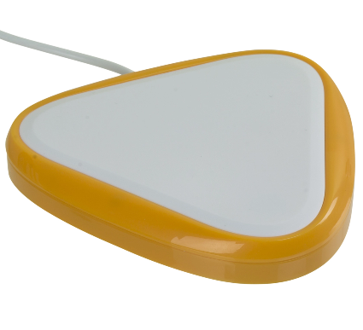

The Big Candy Corn is a large, wired proximity sensor switch that activates when a user’s body is within 2.5 cm (1-inch) of the switch top. This device features visual and auditory feedback and a 3.5 mm (0.125-inch) mono switch plug.

You can buy this accessory from [Spectronics](http://www.spectronics.com.au/product/big-candy-corn-proximity-sensor-switch), [Communicate AT](http://www.communicateat.com.au/big-candy-corn-proximity-switch.html) and [Zyteq](http://www.zyteq.com.au/products/switches_and_connectors/big-candy-corn-proximity-switch).

More information on:

[Big Candy Corn Proximity Sensor Switch](https://www.ablenetinc.com/big-candy-corn-switch)

### AbleNet Little Candy Corn Proximity Sensor Switch

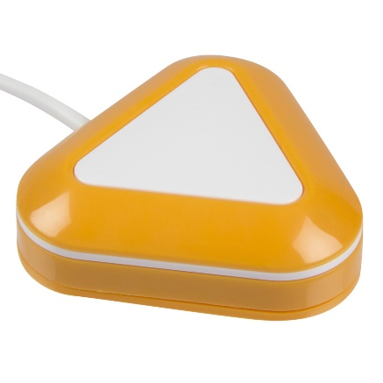

The LITTLE Candy Corn proximity sensor switch has a compact size of 5.0 cm (1.9-inch) wide activation area. It is highly sensitive and does not require a physical touch from the user to activate. Simply wave a hand or move your body within 1.0 cm (0.5-inch) of Candy Corn and it activates. Visual and auditory cues occur when the switch is activated.

You can buy this accessory from [Spectronics](http://www.spectronics.com.au/product/candy-corn-proximity-switch), [Communicate AT](http://www.communicateat.com.au/little-candy-corn-proximity-switch.html) and [Zyteq](http://www.zyteq.com.au/products/switches_and_connectors/candy_corn_proximity_switch).

More information on:

[Little Candy Corn Proximity Sensor Switch](https://www.ablenetinc.com/little-candy-corn-switch)

### HoneyBee Proximity Switch

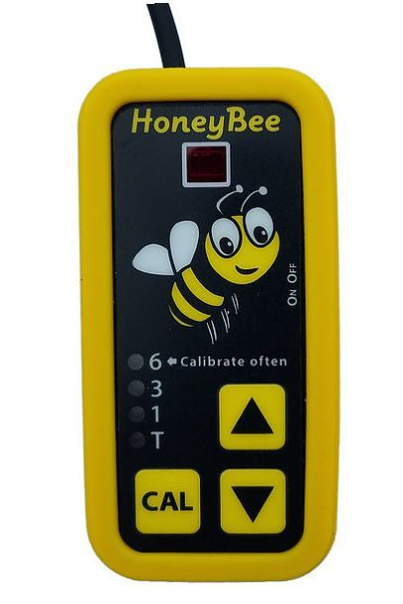

The HoneyBee senses the proximity of a hand, finger, head or nearly any object. To activate the HoneyBee, place your hand, head or other body part over the sensor window. When the device has been activated, an audible tone will be heard. The sensing range can be adjusted for four distance options, allowing for multiple positioning and access needs.

You can buy this accessory from [Spectronics](http://www.spectronics.com.au/product/honeybee-proximity-switch).

More information on:

[HoneyBee Proximity Switch](https://www.adaptivetechsolutions.com/honeybee-proximity-switch/)

[HoneyBee Proximity Switch User Guide](https://media.wix.com/ugd/b1a4c2_e324c3d558b14027839ec61a934813d6.pdf) (PDF Download)

### Wave Switch, reflective beam sensor

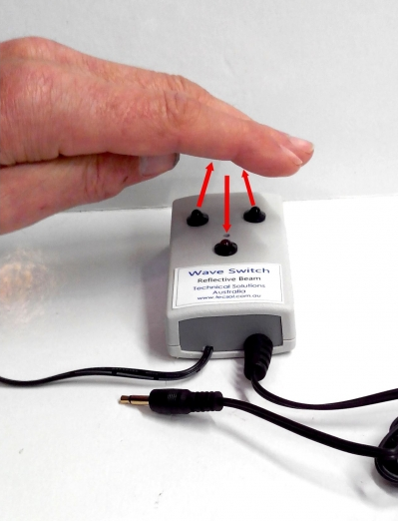

Any movement of your hand, or other body part, within about 5 cm of the sensor will reflect an infrared light beam back to a sensor on the switch box, triggering the switch output. This switch will suit a user who can move their hand at least 3 cm, in and out of the beam area. Key features of this device include:

* Gross movements can trigger the switch
* No pressure is required
* Little accuracy is needed as the reflective beam area covers about 3cm x 3cm
* Audible 'click' feedback as well as visual red LED indicator of switch activation

You can buy this accessory from [Technical Solutions Australia](http://tecsol.com.au/cms123/index.php?option=com_virtuemart&page=shop.product_details&flypage=flypage.tpl&category_id=11&product_id=1109&Itemid=53).

More information on:

[Wave Switch webpage at Technical Solutions Australia](http://tecsol.com.au/cms123/index.php?page=shop.product_details&cid=6&part=subcat&flypage=flypage.tpl&product_id=1109&category_id=83&option=com_virtuemart&Itemid=87)

## Is there any training available for these accessories?

Training and demonstrations might be available directly from the retailers.

Some of these accessories might be displayed and available for demonstrations at [Independent Living Centre Australia](https://ilcaustralia.org.au/search_category_paths/948). Please contact ILC by calling 1300 885 886 for further information.